Project Design Phase-I

# Solution Architecture

|  |  |
| --- | --- |
| Date | 06 May 2023 |
| Team ID | NM2023TMID07991 |
| Project Name | The issue tracker: A reliable complaint management system for improved customer service |

**Solution Architecture:**

he following are some of the key components of a reliable issue tracker architecture:

* A user-friendly interface: The issue tracker should be easy for customers to use, regardless of their technical expertise. The interface should be intuitive and easy to navigate, and it should provide customers with all the information they need to submit a complaint.
* A robust search function: The issue tracker should have a powerful search function that allows customers to quickly find the information they need. The search function should be able to search by issue type, product, date, and other criteria.
* A centralized database: The issue tracker should store all complaints in a centralized database. This will allow customer service representatives to easily access and track complaints.

# Example - Solution Architecture Diagram:

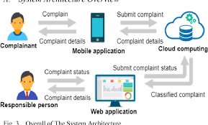

**SOLUTION ARCHITECTURE FOR COMPLAINT MANAGEMENT SYSTEM**